Generative AI
It is a type of AI that can create new, original content; text, image, music, code.
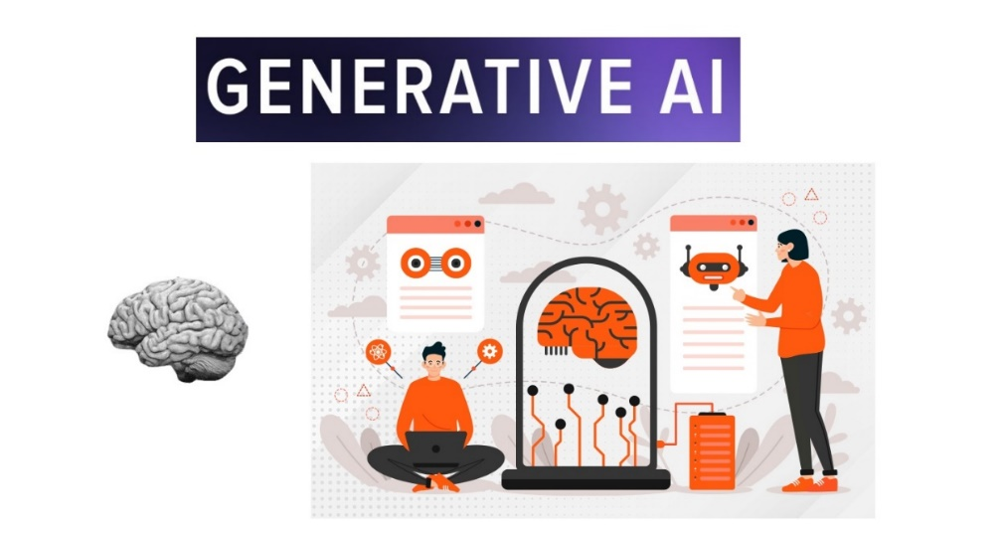

What Generative AI Does
- Text → LLMs (like GPT) can generate articles, stories, code, or chat responses.
- Images → Models like Stable Diffusion or DALL·E can create original pictures, art, and designs.
- Music & Audio → Tools like Suno, Jukebox, and OpenAI’s Whisper (for speech) generate music or voice.
- Code → Models like Codex, GitHub Copilot, Code Llama can generate and autocomplete code.
- Video & 3D → Emerging tools like Runway, Pika Labs, Sora create short videos and animations
- Charts → Models like RapidMiner, DataRobot, Charticulator can generate charts.

Types of Generative AI Models:
- Generative Adversarial Networks, or GANs.
Popular models for image generation and known for creating highly realistic visuals.
It consists of two neural networks:
Generator tries to create realistic images.
Discriminator tries to tell whether those images are real or fake.
عبارة عن مجموعة نماذج بتقدر تنشأ او تولد النصوص او صور او الفيديوهات او الصوت شبيهه بالحقيقه Generator
المعيار| المميز وهو اللى بيقيس مدى واقعية البيانات بمختلف اشكالها Discriminator
وهنا النماذج بتبدأ تتطور من خلال المرحلتين دول لحد ما الموديل يطلع بيانات اقرب للحقيقه
مثل الفن والابداع الرقمى لاستخراج الصور ف الإعلانات والتسويق
تعديل الصور من الضوضاء وغيرها من الصور والفيديوهات

- Variational Autoencoders, or VAEs.
Reconstruction data and generating new variants of it by learning a latent space representation.
Encode data into a lower-dimensional space(latent space), captures the features of the data; The model then decodes from this space to create new variations of the original data.
(Lower- dimensional = vectors = numerical values)
نماذج تعمل على كل أنواع المدخلات بيانات او صور او غيره وبيتم عمل ضغط او تشفير ليها بحيث يطلع منها الداتا المهمة اللى من خلالها يقدر يفك التشفير تاني ويطلع داتا او بيانات جديدة بمختلف اشكالها.
مثل توليد الصور او الفيديوهات.

- Transformer Models, like GPT (2017)
Highly effective at generating text and understanding language because of their self-attention mechanism.
It understands the context and relationships between words and generates a coherent story.
Used for chatbots, text generation and even code writing.

النماذج التحويلية او التوليدية التي تهتم بانشاء النصوص و الترجمة الالية والاجابات على الأسئلة.
2017 اول ظهروها , معالجة وفهم اللغة الطبيعية, النموذج بيركز على محتوى معين ليفهم السياق.
مثل الشات بوت واللى بيساعدنا.
- Autoregressive Models
These models generate data sequentially, one element at a time.
Each new element (like a word, pixel, or sound sample) is generated based on all the previous ones.
So, the model “predicts what comes next” step by step.
- Example: GPT (Generative Pre-trained Transformer)
It generates text word by word, each time using all the previous words as context.
- Use cases: Text generation, code generation, music composition, etc.
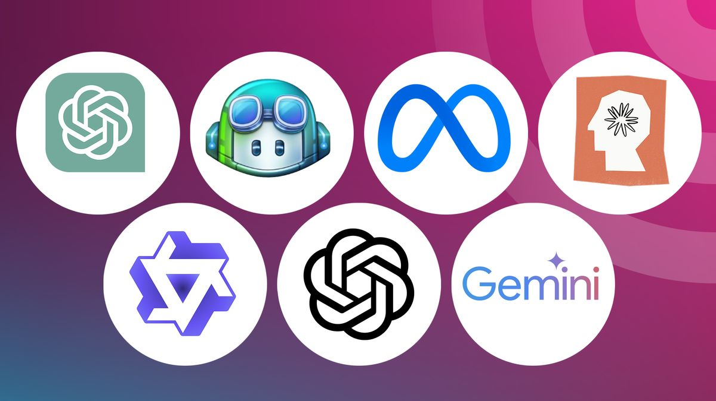
Large Language Mode (LLM):
It is an AI system/program trained on vast amounts of text data (books, websites, etc.) to understand, generate, and manipulate human-like language.
LLMs don’t "think"—they predict words (tokens) based on patterns they’ve seen/learnt before.
Examples:
OpenAI's GPT-4 (ChatGPT), Google's Gemini (formerly Bard), Meta's LLaMA

LLMs power chatbots, virtual assistants, content generation, coding tools (like GitHub Copilot), and more.
In training phase, it uses transformer model to understand the context and the relationship between words. And uses autoregressive model to predict and generate the response word by word (tokens).

LLMs Processing Pipeline:
Step 1: User Input (Prompt)
- User enters raw text → "Hello, how are you?".
- User uploads file.

Step 2: Tokenization
- "Hello, how are you?" → [15496, 11, 703, 389, 345] = TOKEN IDS
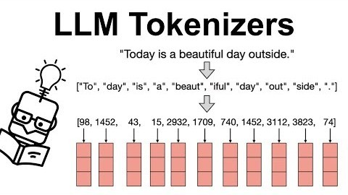
- A tokenizer converts raw text (Unicode string) into a sequence of discrete tokens (usually integers).
- The model never sees strings — it only sees token IDs → embeddings → transformer layers → token IDs → decoded text.
- The SDK sends the prompt to LLM provider → provider converts the prompt into tokens →
provider sends the tokens to the model.
- Each modal has a context window (e.g., 4k, 32k tokens)

Step 3: Embedding
- An embedding is a vector (list of numbers) that represents the meaning of a token, word, or sentence.
- The goal: put similar meanings close together in vector space
- "cat" → [0.12, -0.8, 0.33, …]
🔹 Types of Embeddings
- Token Embeddings → each token ID gets a vector from an embedding table.
  - Example: Token 345 ("dog") → [0.15, -0.75, …].
- Positional Embeddings → add info about word order.
  - "dog chased cat" vs "cat chased dog" would otherwise look the same.
- Sentence/Document Embeddings → average or transform token embeddings to represent larger chunks (used in search, RAG, clustering).

We embed tokens because it lets the model build contextual meaning step by step, instead of locking the whole text into a single static vector from the start

Step 4: Positional Embedding
- Transformers process tokens in parallel (not sequential like RNNs).
- That means they don’t know the order of words unless we add extra information.
- Example:
  - "The dog chased the cat"
  - "The cat chased the dog"
→ Same tokens, but completely different meaning!

So we need a way to inject order information into token embeddings.

- Absolute Positional Encoding (classic Transformer)
  - Add a unique vector for each position in the sequence.
  - Often sinusoidal functions (sine, cosine) are used so the encoding has a predictable pattern.

- Learned Positional Embeddings
  - Instead of using fixed sinusoidal values, each position has a trainable vector.
  - The model learns the best encoding during training.

Step 5: Transformer Layer
- Input embeddings of all tokens (token embedding + positional encoding).
- Example: for "The cat chased the dog", you have a matrix where each row = one token vector.

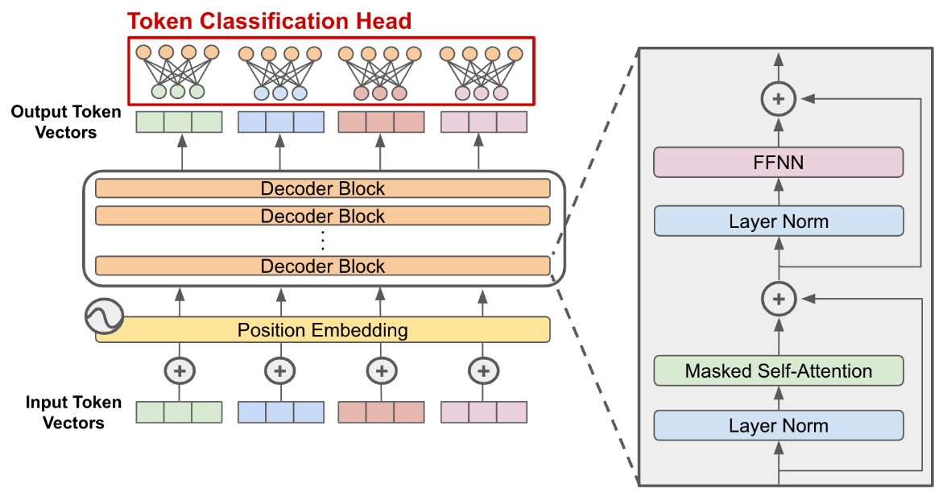
1️⃣ Masked/Multi-Head Self-Attention (MHA)
- When generating text, each token can only “look at” previous tokens, not future ones.
- This prevents the model from “cheating” by seeing the word it’s supposed to predict next.
  - Each token embedding is projected into three vectors:
    - Q (Query) → what am I looking for?
    - K (Key) → what do I offer?
    - V (Value) → what information do I carry?
  - Attention score = Q · K (dot product).
  - Weighted sum of V = new representation for each token.
📌 After masked self-attention, each token embedding:
  - Contains information from itself (the original embedding).
  - Contains information from all previous tokens in the sequence (context).
  - Does not see future tokens (because of masking).
  - Each token now “knows” about the relevant words that came before it, which is crucial for tasks like language modeling or text generation
📌 Multi-head: Instead of one attention calculation, multiple "heads" run in parallel.
  - A single attention might only capture one type of relationship between tokens.
  - Multi-head attention allows the model to look at multiple relationships simultaneously.
  - One head may focus on syntax (subject → verb).
  - Another on long-distance references.
  - Another on semantic roles.

📌 Each head focuses on different aspects:
- Head1 → syntax (subject-verb agreement)
- Head2 → semantics (meaning of words)
- Head3 → long-range dependencies (words far apart)
Result: Each token embedding now contains richer contextual information from multiple perspectives.

✅ Summary:
- Masked Attention: token sees only past + current tokens → learns context.
- Multi-Head: token sees multiple types of relationships → richer, more nuanced context.

2️⃣ Feed-Forward Network (FFN)
- After Self-Attention, each token already has a contextual embedding (it “knows” about other tokens), each token’s embedding has been updated with information from other tokens.
👉 But the model still needs to transform and refine these embeddings.
- It’s a small neural network applied to each token embedding individually.
- Usually: two linear layers + ReLU/GELU activation.
- Expands embedding dimension → projects back → gives richer features.

📌 The purpose of the FNN in a Transformer is to add non-linear, token-wise transformations that expand model capacity, let each token process what it learned from attention, and enable the LLM to represent complex patterns beyond simple token relationships.

Example:
For the sentence:
"The cat sat on the mat because it was tired."
- The word "it" refers to "cat" (not "mat").
- The attention mechanism helps the LLM understand this link.

Step 6: Output Layer (Softmax)
- After transformer layers, we have hidden states for each token
- Softmax converts logits into a probability distribution over all tokens.
- The output Softmax layer turns hidden states into probabilities for the next token in the sequence.

Step 7: Encoding
- Tokens are converted back into human-readable text.

The output layer does NOT directly output embeddings or tokens — it outputs probabilities over tokens, and then a decoding step turns those probabilities into tokens.

Embeddings → Transformer → Logits → Probabilities → Tokens

Key Components of LLMs
Component | Role
Transformer | Neural network architecture enabling parallel processing.
Attention Mechanism | Helps the model focus on relevant words in a sentence.
Embeddings | Converts words into numerical vectors.
Parameters | Weights learned during training (e.g., GPT-3 has 175B parameters).
Prompt Engineering | Crafting inputs to get better outputs.

Limitations of LLMs
Problem | Why It Happens
Hallucinations (Making up facts) | LLMs guess words—they don’t "know" truth.
Bias (Unfair opinions) | Trained on human data, which has biases.
No Real Understanding | It’s pattern-matching, not true intelligence.

Example:
If you ask: "What’s 1,000,000 ÷ 0?"
An LLM might guess an answer (even though it’s impossible) because it’s predicting text, not doing math.
Pre-training (Unsupervised Learning)
- The model learns to predict the next word in a sequence (masked language modeling).
When you type:
"The sky is ___"
The LLM calculates:
- "blue" (70% chance)
- "gray" (20% chance)
- "falling" (0.1% chance)
It picks the most likely word (or a random one if you want creativity).
This is how ChatGPT writes entire paragraphs!
How LLMs Generate Text (Inference)?

When you ask an LLM a question:
- Your input is tokenized.
- The model computes probabilities for the next best word.
- It generates text sequentially (word by word).
- Uses sampling techniques (e.g., temperature control) to avoid repetition.

How to Build with LLMs?
As an AI-Agent Developer, you can:
- Use APIs (OpenAI, Gemini, Anthropic).
- Fine-tune open models (LLaMA, Mistral).
- Optimize with RAG (Retrieval-Augmented Generation).
- Deploy autonomous agents (AutoGPT, BabyAGI).

How Can You Use LLMs?
- Chatbots (Customer service, personal assistants).
- Writing Help (Emails, essays, stories).
- Coding (GitHub Copilot writes code for you).
- Education (Explaining complex topics simply).

How to choose LLM models?
3 Key Metrics: Quality, Speed, and Price.
Extend Metrics: Latency and Context Window.

🔍 LLM Augmentation Flow:
It is a way of enhancing LLM capabilities by connecting it to external systems or knowledge, so it can do more than just generate text from its pre-trained memory.

Augmentation Flow solves LLM limitations by adding components around the LLM to:
- Access external knowledge (documents, APIs, databases).
- Remember past interactions.
- Use tools or take actions.
- Think step-by-step and correct itself.

1. User Prompt/ Input:
The process begins with a user message, request, or instruction.
📥 Example:
“What’s the weather like in Cairo today?”
This is natural language input that will be passed to the LLM.

2. Prompt Engineering/ Instruction Tunning:
The Prompt is simply the input or instruction you give to an LLM to guide its response.
The LLM now reads the input and tries to understand:
- What is the user asking?
- Can I answer this from my pre-trained knowledge?
- Do I need help from a tool or external system?
This is the “thinking step” — the model is using pattern recognition, semantics, and intent parsing.

Prompt Elements:
These are the parts or pieces you can include in your prompt to make it better.
🔹 Think of it like writing a recipe:
You don’t just say, “Make food.”
You say:
- What you want (📌 Instruction)
- The ingredients (📌 Input or context)
- The format you want it in (📌 Output format)
- And maybe an example (📌 Example)

🧱 Common Elements
Element | Meaning | Example
Instruction | What should the AI do? | "Translate this to Arabic."
Input / Data | The content to work on | "Hello, how are you?"
Context | Extra background info | "You’re working for a travel company."
Output Format | How should the response look? | "Give the result as a list."
Example | Show an input and the correct output | "Input: X → Output: Y"
Constraints | Rules to follow | "Use less than 100 words."

Prompt Roles:
Sometimes we tell the AI to "act like someone." That is called a Role.
You're assigning a character or persona to the AI.

🧍 Examples of Roles
Role | Meaning | Example
System / Expert | Make the AI act like a specialist | "You are a senior doctor."
User | The person giving instructions | "How do I cure a headache?"
Assistant | The AI answering the question | "You can take ibuprofen..."

💡 This is useful when you want:
- Expert answers
- A specific tone (e.g., friendly, technical, formal)
- Specialized behavior (e.g., agent, analyst, teacher)
Example:
- You are a professional resume reviewer. (← Role)
- Please review the following CV and suggest improvements. (← Instruction)
- CV: “Eslam Heikal...” (← Input)
- Give your feedback in 3 bullet points. (← Output format)
- Do not change the personal details. (← Constraint)
✅ Augmentation Flow Vs Augmentation Techniques:
Concept | LLM Augmentation Flow | LLM Augmentation Techniques
What it is | A full step-by-step process that describes how the LLM interacts with tools and data | The specific methods used to help the LLM get better answers
Think of it like | The movie script or workflow | The special effects or tricks used in the movie
Purpose | Shows how LLM becomes an intelligent agent over time | Gives the LLM extra powers: search, memory, tools, etc.
Examples | Thought → Tool Call → Observation → Reasoning → Answer | Retrieval Augmentation, Tool Use, Memory Injection, Function Calling

🔍 LLM Augmentation Techniques
They are methods used to give LLMs capabilities beyond their pre-trained knowledge, such as:
- Accessing external knowledge
- Performing actions or calculations
- Remembering past interactions
- Making multi-step decisions.

1. 🧾Retrieval-Augmented Generation (RAG)
Pulls relevant context from a vector DB or document store (e.g., PDF, websites).
How it works:
- User asks a question
- System retrieves relevant documents from a database
- LLM uses those docs to answer
📦 Used in: chatbots, document Q&A, enterprise assistants
Example:
"What is in our company vacation policy?"
The system fetches the HR PDF → LLM reads the relevant part → Gives accurate answer.

2. ⚙️ Tool Use (Function Calling / Plugins)
Lets the LLM use external tools or APIs like calculators, calendars, weather services, etc.
How it works:
- LLM decides: “I need to use a tool”
- It forms a function call like getWeather("Cairo")
- Tool returns the result
- LLM includes the result in its answer
📦 Used in: agents, automation, planning assistants
Example:
"What’s the weather in Cairo?"
→ LLM calls a weather API → gets “35°C, sunny” → includes it in the response.

3. 🧠Memory & Long-Term Context
Gives the LLM a memory of past interactions, user preferences, or context.
How it works:
- Stores important facts about the user
- Reinjects them into future prompts
📦 Used in: long conversations, user profiles, personal agents
Example:
User: "Remind me next time that I like my meetings short."
→ Stored in memory
→ Future: "Based on your preference, I made this agenda brief."

4.🧩 Action Planning
Combines thoughts and actions: lets the LLM think step-by-step, use a tool, then reflect.
How it works:
- Think: “I need to calculate this”
- Act: Call a tool
- Observe: Read the result
- Reflect: Decide what to do next
📦 Used in: agents, planning, puzzles, multi-step problems
Example:
"How many days until next Friday?"
→ Think → Use date tool → Read “5” → Reply: “It’s in 5 days.”
Popular techniques:
- ReAct (Reason + Act)
- MRKL (Modular Reasoning)
- LangGraph / AutoGPT / BabyAGI

5. 📤Feedback & Critique Loops
- LLM critiques or self-edits its own outputs.
- Example: “Give me a better version of your answer using more technical terms.”

Advanced Prompt Techniques
Ways to optimize interactions with AI models.

1. Zero-Shot Prompting
- It is the simplest and most widely used prompt technique when working with LLM.
- It is a method where you ask a language model (like Ollama, ChatGPT, or Llama) to perform a task without providing any prior examples and without any prompt elements.
- The model relies solely on its pre-trained knowledge and the instructions given in the prompt itself.

Examples:
1. Text Classification.
Is the following sentiment positive, negative, or neutral?
"I loved the movie, the acting was fantastic!"
2. Translation.
Translate this sentence to French:
"Hello, how are you?"
3. Summarization.
Summarize this paragraph in one sentence:
[Long paragraph about climate change...]
4. Question Answering from history data.
What is the capital of France?

2. One-Shot Prompting
- Provide one example before asking the model to generate a response followed by the actual input.
- Gives the model a bit of direction by showing it a signal instance of what you want.
- One-shot prompting is a lightweight way to improve accuracy without overloading the model with examples.

Structure
[Example Input] → [Example Output]
[New Input] → [Model Generates Output]
Example
Classify the sentiment of this sentence: "I love this movie!" → Positive
Now classify: "This product is terrible." → [Model outputs: Negative]

3. Few-Shot Prompting
- Provide multiple examples (typically 2-5) to help the AI model understand and replicate a task.
- It bridges the gap between zero-shot (no examples) and fine-tuning (training on massive datasets).

Structure
Example 1 Input → Example 1 Output
Example 2 Input → Example 2 Output
New Input → [Model Generates Output]

Example
Input: "Extract name and age: 'John is 30.'" → Output: {"name": "John", "age": 30}
Input: "Extract name and age: 'Alice is 25.'" → Output: {"name": "Alice", "age": 25}
Input: "Extract name and age: 'Bob is 40.'" → [Model predicts: {"name": "Bob", "age": 40}]

4. Chain-of-Thought Prompting (CoT)
- It is a reasoning technique that forces AI models to break down problems step-by-step before answering, mimicking human-like logical reasoning.
- It significantly improves performance on complex tasks like math, logic, and strategy problems.

How Chain-of-Thought Works
- Ask the model to "think aloud" by showing intermediate reasoning steps.
- The model decomposes the problem instead of jumping straight to the answer.
- Produces more accurate results for multi-step problems.

Structure
Question: [Complex problem]
Reasoning: Let’s think step by step...
1. [Step 1]
2. [Step 2]
...
Final Answer: [Correct result]

Example
Q: "If I have $100 and buy 3 books at $20 each, how much money is left?"
A: Step-by-step:
1. Cost of books = 3 × $20 = $60.
2. Remaining money = $100 - $60 = $40.
Final Answer: $40

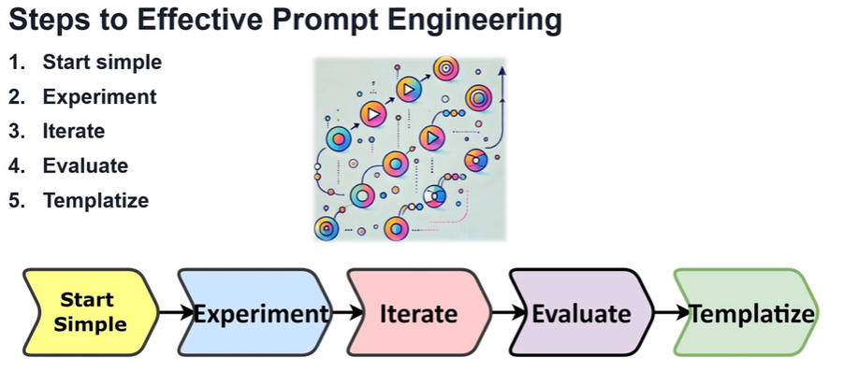
1. Start Simple
- Begin with a clear, concise prompt to establish a baseline.

Why?
Avoid overwhelming the model with unnecessary complexity.

Example
- ❌ Overly complex:
"Explain quantum computing in detail, including qubits, superposition, entanglement, and compare it to classical computing in a table."
- ✅ Simple:
"Explain quantum computing in 1-2 sentences."

Key Tip: Use direct language and single-task prompts initially.

2. Experiment
- Test variations or different structures to improve output quality.
- You can use a few-shot prompting to include one or two examples.

Why?
Small tweaks can significantly alter results.

Experiments to Try
- Add context:
"Explain quantum computing to a 5-year-old." vs. "Explain quantum computing to a physics student."
- Change formats:
"Summarize this article in bullets." vs. "Rewrite this article as a poem."
- Adjust tone:
"Write a formal email rejecting a job applicant." vs. "Write a friendly rejection email."

Key Tip: Use A/B testing to compare prompt versions.
3. Iterate
- One of the most important strategies is to test and iterate with different inputs.
- Refine prompts based on experimental results.
- If the response is too broad, make your prompt more specific.

Why? Continuous improvement leads to optimal performance.

Iteration Process
- Analyze failures: Did the model misunderstand? Add clarifications.
  - Original: "Translate this to French." → Fails if no text is provided.
  - Improved: "Translate '[text]' to French."
- Reduce ambiguity:
  - Original: "Write a story." → Too vague.
  - Improved: "Write a 100-word horror story about a haunted lighthouse."

Key Tip: Document changes to track what works.

4. Evaluate
- Measure output quality against objectives.

Why? Ensures the prompt meets your needs.

Evaluation Criteria:
- Accuracy: Does the output match facts?
- Relevance: Is it on-topic?
- Consistency: Similar inputs → Similar outputs?

Example Evaluation:
- Prompt: "Summarize this news article in 3 sentences."
- Check:
  - Did it capture key points?
  - Is the length correct?

Key Tip: Use rubric or scoring systems for objectivity.

5. Template
- Create reusable prompt structures for efficiency.

Why? Saves time and ensures consistency.

Template Examples:
- Customer Support: "Respond to [customer query] in a [tone] tone. Include: [key points]."
- Data Extraction: "From [text], extract [entities] as a JSON list with keys: [keys]."
- Translation: "Translate '[text]' from [language] to [language]."

Key Tip: Use placeholders (e.g., [text]) for customization.
Retrieval-Augmented Generation (RAG)
Traditional LLMs (like GPT-4, Claude, etc.) have two main limitations:
- Knowledge Cutoff → Models don’t know recent or domain-specific information unless retrained.
- Hallucination → Models can generate fluent but incorrect answers when they don’t have the facts.

Enhances the model’s ability to generate more accurate, relevant information and context-aware; By integrating external knowledge/resources into the response.
Bridges the gap with pre-trained knowledge and the real-time information that is not part of its training data.
Pull in information from real-time or external knowledge sources, make responses more accurate and relevant to specific queries.
Basics of RAG
- Retrieval: Fetch relevant documents/data from a knowledge base.
- Augmentation: Inject retrieved context into the prompt.
- Generation: The LLM generates answers grounded in the retrieved data.

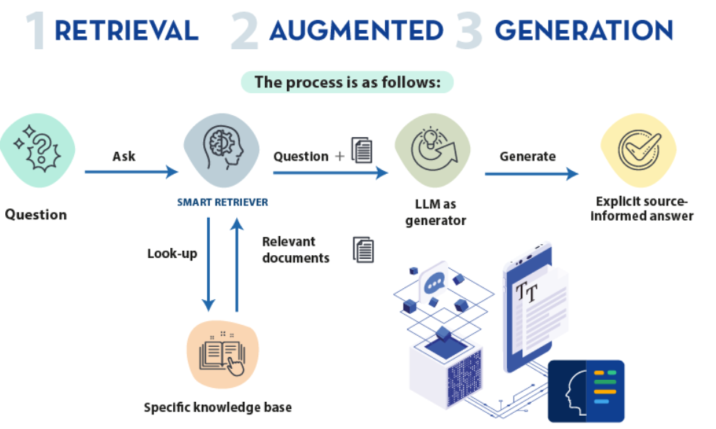
Why Do We Need RAG?
- RAG Solves the Problem of Static Knowledge: It retrieves real-time information.
- Access to External Sources: RAG pulls from documents, databases, and APIs.
- Combines Knowledge with Context: Bridges the gap between general knowledge and specific, up-to-date information.
How does RAG Work?
1. Ingestion.
Gather information from a wide variety of sources—from databases, documents, real-time information from APIs and Organize it. and ensures data is searchable.

Steps:
- Collect: Gather raw data (PDFs, FAQs, databases, research papers).
- Chunk: Split documents into smaller pieces (e.g., 500-token sections).
- Embedding: Convert text into numerical vectors using an embedding model.
  - Embeddings are numerical representations of text that capture the semantic meaning of words and phrases
  - Embedding models (text-embedding-3-small, bge-small) for Transforms text into numerical vectors (embeddings).
  - Encodes semantic meaning of the text.
  - Enables to perform similarity-based retrieval 'car' and 'automobile' have similar embeddings.
  - Find documents that semantically relate to the user’s query

- Store: Save vectors in a searchable database (e.g., Pinecone, Chroma).
  - A specialized database for storing high-dimensional vectors.
  - Stores millions of vectors and access data efficiently during retrieval.
  - Optimized for similarity-based searches, quickly find the closest vectors.
  - Vector Search to find documents that are semantically similar to the query.

Example:
- A support manual is split into sections like "Troubleshooting Wi-Fi" → Embedded → Stored in a vector DB.
Why? Enables fast, semantic search during retrieval.
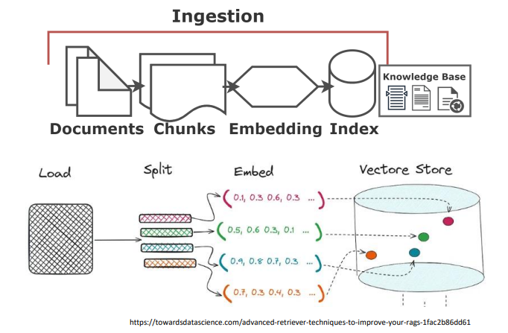
2. Retrieval
- Search through the knowledge base: internal databases, documents, or external sources
- Fetching relevant context for a user query.

Steps:
- Embed the Query: Convert the user’s question/prompt into a vector.
  - Query is passed through the Embeddings Model, like the documents were, to convert it into its vectorized form.
- Search: Find the top-*k* most similar document chunks from the vector DB.
  - Query can be compared with the vectors representing the documents in the Vector Store.
  - Match the meaning of query with content in the knowledge base.
  - Use similarity metrics to identify which vectors are closest in meaning to the query.
  - Retrieves a subset of vectors that correspond to the most relevant documents.
- Optional Refinement:
  - Rerank results (e.g., using bge-reranker).
    - Ensures the response is accurate and relevant.
    - After retrieval, documents are ranked based on relevance to the query.
    - Ensure that the most useful information is prioritized.
    - Filters out any irrelevant or inconsistent information.
    - Ensure that the final response is as accurate and helpful as possible.
  - Expand the query with synonyms (e.g., "reset" → "restart").
- Context Query Prompt:
  - Combines retrieved documents with the original query to create a context-rich query prompt.
  - Enriches the query by adding specific information from the retrieved documents, detailed understanding of what the user is looking for Nuanced insights into both the user’s question and the relevant knowledge from the documents.
  - Prepares it for the generation phase.
Why? Ensures the LLM receives accurate, up-to-date context.
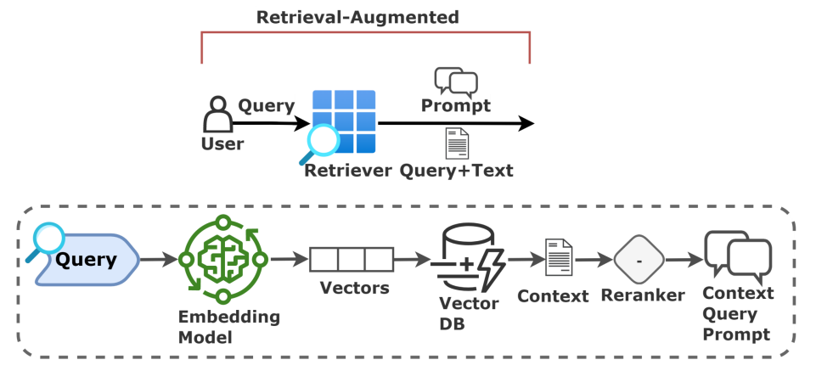
3. Generation (LLM)
Producing a natural-language answer using retrieved data.
The LLM synthesizes the context query prompt

Steps:
- Augment the Prompt: Combine the query + retrieved context into a structured prompt.
  - Produces a fact-based, contextually accurate response.
- Generate: The LLM (e.g., GPT-4, Llama 3) crafts a response grounded in the context.
  - Combines specific document knowledge with the LLM’s broader understanding.
  - Ensures the response is accurate, relevant, and up to date.
- Output: The system delivers the generated response to the user.

Why? Combines the creativity of LLMs with factual accuracy.
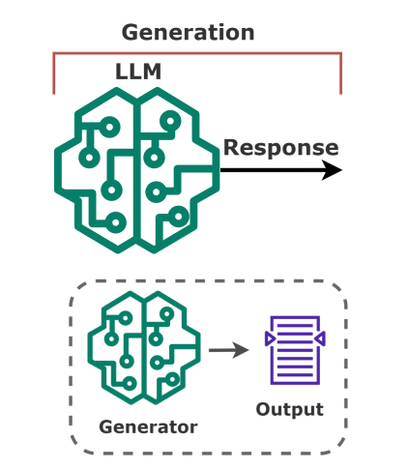
Vector Database
- It is a specialized database designed to store, manage, and query high-dimensional vectors.
- A database optimized for vector embeddings (numeric representations of text/images).
- Vectors are numerical representations that capture the semantic meaning of data
("Find tickets similar to this one").
- Indexes and stores vector embeddings for fast retrieval and similarity search.
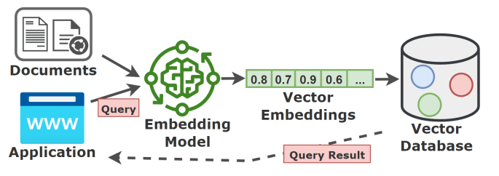
- Enable contextual searches based on the meaning behind the data.

Terms
Term | Explanation | eShop Example
Embedding | Numerical representation of data | XtremeBass 3000 → [0.2, -0.5, 0.7,...]
Similarity | Cosine/euclidean distance between vectors | Finds tickets with similar issues
Index | Optimizes vector searches | Like a book index for fast lookup

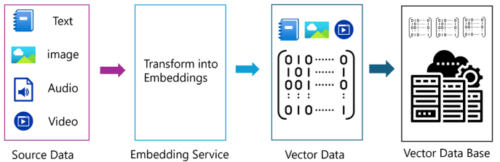

What is a Vector?
A vector is a mathematical object that has both magnitude and direction, represented as a list of numbers: [1.2, 3.4, -0.8]
A vector is just a list of numbers that represents data (text, images, etc.) in a way computers can understand.
"Headphones won't turn on" → [0.12, -0.45, 0.23, ..., 0.76] (1536 numbers total)
Vectors are used to represent complex data in a way that AI models can process, numerical summaries of information.
What are Vector Embeddings?
It’s a way to convert a text to numerical representations of data, capture the semantic meaning of text, images, audio or other data types.
Steps
Step 1: Input Data
Start with raw data, like a sentence, an image, or a sound file.
Step 2: Use an AI Embedding Model
Pass the data through an AI model, like a Transformer model.
Step 3: Output Embedding
Transforms the input into a vector embedding, list of numbers.
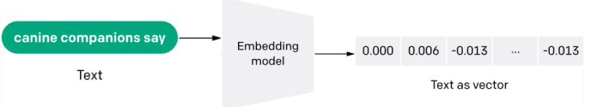
Core Processes in Vector Databases

1 - Vector Creation - Building the Vector Store
- Data (text, images, audio) is processed using a pre-trained embedding model.
- OpenAI’s text-embedding-ada or Hugging Face’s all-MiniLM are commonly used.
- Converts the input into a high-dimensional vector.
- These embeddings are stored in the Vector Database.
- Embeddings and associated metadata are stored in the database.
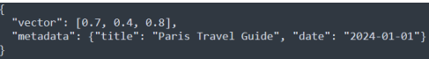
- A product catalog uses embeddings for descriptions and stores metadata like product names and prices.
2 - Vector Indexing - Organizing the Vectors
- Efficient retrieval in a vector database depends on how the embeddings are indexed.
- Splits vectors into partitions based on similarity to reduce search space.
3 - Vector Search - Finding Similar Vectors
- User query is converted into a vector embedding uses similarity metrics to find the closest matches.
Fine-Tunning
Fine-tuning is the process of adapting a pre-trained model to a specific task.
The model is already trained on large amounts of data but needs to be optimized for domain-specific knowledge.
Fine-tuning allows the model to improve its performance on specialized tasks.

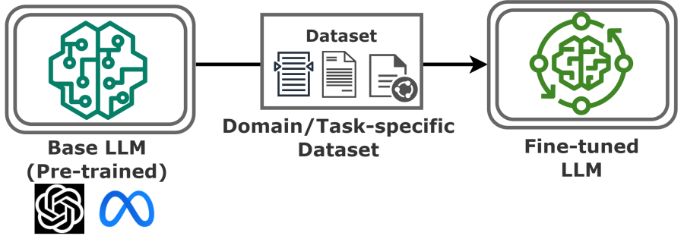

How Does Fine-tunning works?
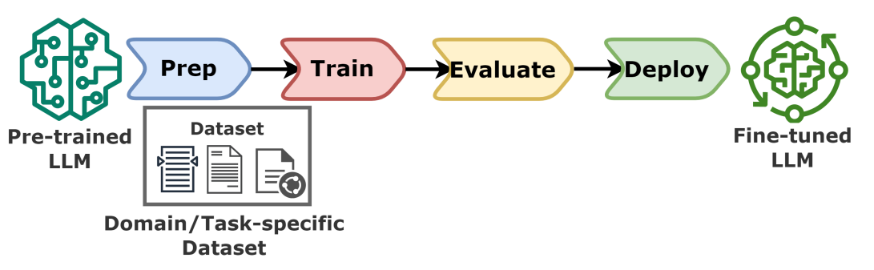
Function Calling
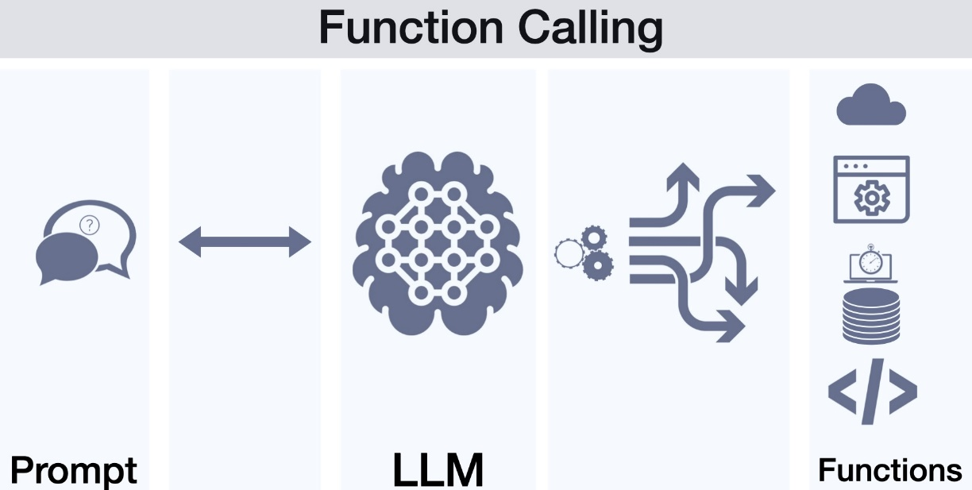
It is a feature that allows (LLMs) to interact with external tools, APIs, or code.
Instead of just generating text, the LLM can detect when it needs real-world data (like weather, stock prices, or math calculations) and trigger a function to fetch that data.

How Does Function Calling Work?
Step 1: User Asks a Question
You ask the LLM something that requires live data, like:
"What’s the weather in New York right now?"
Step 2: LLM Detects a Function is Needed
The LLM doesn’t know the current weather, but it recognizes:
- "This question needs real-time data."
- "I should call a weather API."

Step 3: LLM Generates a "Function Call"
Instead of guessing, the LLM outputs a structured request.
Step 4: Your Code Executes the Function
Your app/system calls a real weather API, gets the data.
Step 5: LLM Gives a Final Answer
The LLM reads the API response and says:
"The weather in New York is 22°C and sunny."

Why is Function Calling Useful?
- Access to Live Data (weather, stocks, news).
- Run Calculations (LLMs are bad at math—let Python handle it).
- Database Queries (fetch user info, orders, etc.).
- Automate Tasks (send emails, control smart home devices).

MCP: Model Context Protocol
MCP is a protocol designed to let LLMs access external tools, APIs, and data sources in a standardized, secure way.

Why does MCP exist?
- To avoid writing custom integrations for every model/vendor.
- To make tools/resources reusable across different LLM apps.
- To give developers and users more security and control when an AI calls external systems.

LLMs frequently need to integrate with
- Additional information like google drive.
- Tool like any database.
- API like GitHub, Slack, Internet, Application API etc.

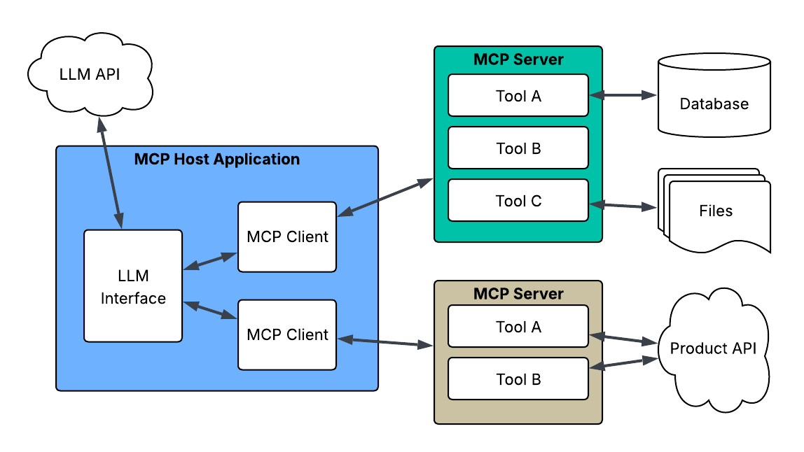
Key Concepts
- Resource: Read-only data the AI can fetch (like a document or config).
- MCP Server: The program you create. It exposes tools/resources (e.g., get_weather).
  - Example: a weather server that exposes get_weather(city).
- Tool (Action): A function you expose. Example: get_weather(city) returns today’s weather.
- MCP Host: The application that runs the LLM and manages integration with MCP providers.
  - Can connect with LLM.
  - Handle the user interface (Chat Window).
  - Connect to MCP providers using a chosen transport (stdio, http).
  - Decides when/how the LLM is allowed to call a tool.
  - Like (Cursor, Claude Desktop).

- MCP Client: “the connection instance” between host ↔ one server.
  - The component inside the host that establishes and manages a connection to an MCP server.
  - Each client manages communication with a single server (via stdio or http)
- Transport: How messages move between host and server (stdio, http).

Transport | When to use | Pros | Cons | Typical host connection
stdio (local process) | Local dev, desktop apps, air-gapped environments | Easiest to run, zero network setup | Not remote; scaling is limited to 1 machine | Host spawns your process and talks over stdin/stdout
http (streamable-http) | Cloud / multi-user / distributed production | Remote access, load balancing, observability, gateways | Requires auth, TLS, ops setup | Host connects via URL with JSON-RPC over HTTP(S)

When to create a custom MCP provider:
- You have unique APIs or data your AI must use.
  - Example: Company’s ERP, HR system, product API, custom knowledge DB.
- You need strict governance around tool access.
  - Example: Only allow LLM to query DB with certain filters.
- You want to encapsulate business logic behind a safe, well-defined schema.
  - Example: Instead of letting AI write SQL → provide get_sales(region, quarter) tool.
- You need reusability across different AI hosts.
  - Example: The same provider can be used in Claude, Cursor, and your in-house .NET app.

EShop Support Example
- It has two pages using the LLM powered capabilities with the integrating prompts.
- The AI helps the support team quickly understand the nature of the issue and how the customer feels, allowing for more efficient handling of the tickets.
- Ticket List Page.
- List customer support tickets in a table format (Id, Type, Status, Title, Satisfaction Score).
- We use AI for
  - Summarization (Title)
  - Classification (Type)
  - Semantic Analysis (Satisfaction Score)
  - Semantic Meaning
- Ticket Detail Page.
- Agents interact with a single customer ticket.
- It contains Q&A Chatbot to query the system.
- Generate a suggested response to the customer.
- We use AI for
  - Summarization (Title)
  - Classification (Type)
  - RAG (Chatbot)

